**Assignment No:-60**

Name:-Suryawanshi Sangramsingh Sambhaji

Batch: - Delta - DCA (Java) 2024 Date:-8/8/2024

CREATE TABLE customers (

id INT PRIMARY KEY,

name VARCHAR(50),

country VARCHAR(50)

);

INSERT INTO customers (id, name, country)

VALUES (1, 'John Smith', 'USA'),

(2, 'Jane Doe', 'Canada'),

(3, 'Mark Johnson', 'USA'),

(4, 'Emily Lee', 'USA'),

(5, 'Peter Kim', 'South Korea');

CREATE TABLE employees (

id INT PRIMARY KEY,

name VARCHAR(50),

age INT,

salary DECIMAL(10, 2)

);

INSERT INTO employees (id, name, age, salary)

VALUES (1, 'John Smith', 25, 60000.00),

(2, 'Jane Doe', 28, 75000.00),

(3, 'Mark Johnson', 32, 90000.00),

(4, 'Emily Lee', 24, 55000.00),

(5, 'Peter Kim', 29, 80000.00);

CREATE TABLE orders (

id INT PRIMARY KEY,

customer_id INT,

order_date DATE,

total DECIMAL(10, 2)

);

INSERT INTO orders (id, customer_id, order_date, total)

VALUES (1, 1, '2022-01-01', 1000.00),

(2, 2, '2022-01-02', 2000.00),

(3, 3, '2022-01-03', 3000.00),

(4, 1, '2022-01-04', 1500.00),

(5, 4, '2022-01-05', 2500.00);

CREATE TABLE products (

id INT PRIMARY KEY,

name VARCHAR(50),

price DECIMAL(10, 2)

);

INSERT INTO products (id, name, price)

VALUES (1, 'Phone', 599.99),

(2, 'Laptop', 1099.99),

(3, 'Tablet', 499.99),

(4, 'TV', 999.99),

(5, 'Camera', 799.99);

Questions:

1) Write a query to retrieve all the rows from a table called "customers" where the country is "USA".

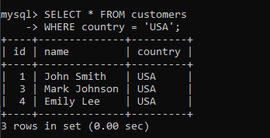

2) Write a query to retrieve the names and ages of all the employees from a table called "employees" where the age is between 20 and 30.

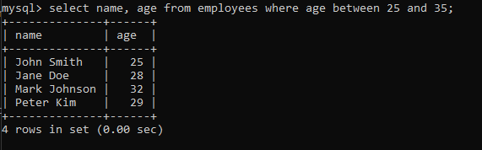

3) Write a query to retrieve the total number of orders made by each customer from a table called "orders".

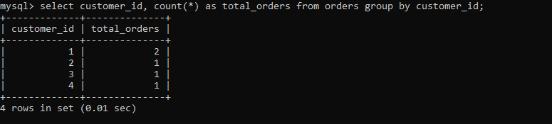

4) Write a query to retrieve the names and prices of all the products from a table called "products" where the price is greater than 100.

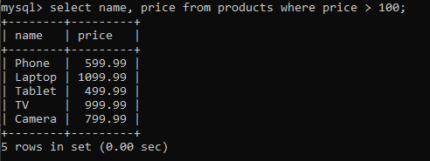

5) a query to retrieve the names and addresses of all the customers who live in a city called "New York" from a table called "customers".



6) Write a query to retrieve the names and salaries of all the employees from a table called "employees" where the salary is greater than 50000.

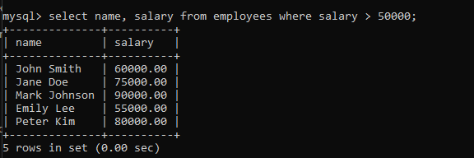

7) Write a query to retrieve the names and ages of all the employee from a table called " employee " where the age is not null.

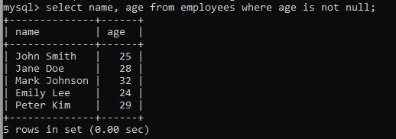

8) Write a query to retrieve the names and prices of all the products from a table called "products" where the price is between 50 and 100.



9) Write a query to retrieve the names and addresses of all the customers who live in a state called "California" from a table called "customers".



10) Write a query to retrieve the names and salaries of all the employees from a table called "employees" where the salary is between 50000 and 100000.

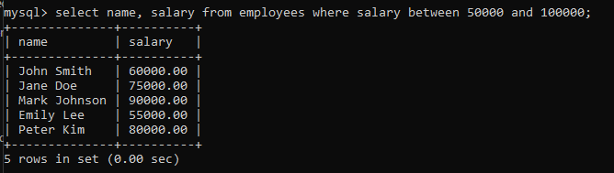

11) Write a query to retrieve the names and prices of all products in the "Electronics" category.



12) Write a query to retrieve the names and email addresses of all customers who live in the USA.

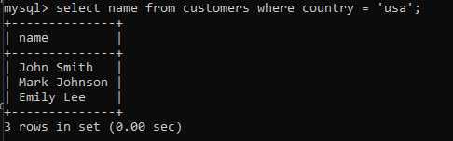

13) Write a query to retrieve the names and salaries of all employees who work in the "Sales" department.

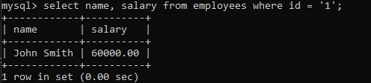

14) Write a query to retrieve the order dates and total amounts of all orders placed by customer ID 3.

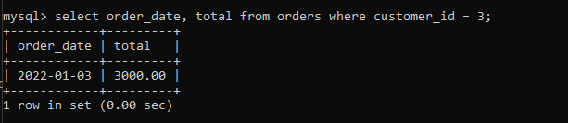

15) Write a query to retrieve the names and prices of all products with a price greater than 500.

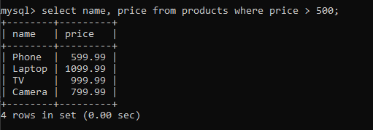

16) Write a query to retrieve the names and ages of all employees in the "Marketing" department.

17) Write a query to retrieve the names and countries of all customers who have placed an order.

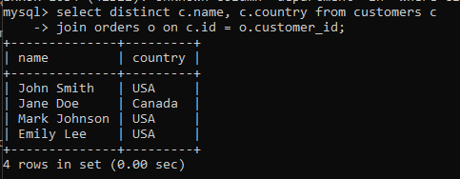

18) Write a query to retrieve the names and ages of all employees who have a salary greater than 50,000.

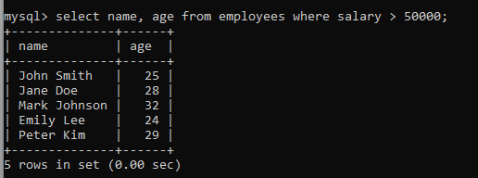

19) Write a query to retrieve the order dates and total amounts of all orders placed for the product with ID 2.

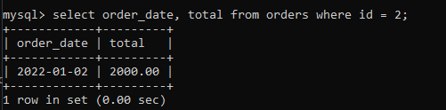

20) Write a query to retrieve the names and prices of the three most expensive products.

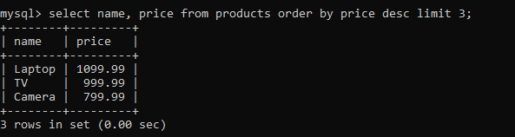

21) Write a query to retrieve the names and emails of all customers who have not placed any orders.

select name, email from customers where id not in (select distinct customer_id from orders);

22) Write a query to retrieve the names and salaries of all employees who have a manager ID of 2

select name, salary from employees where manager_id = 2;

23) Write a query to retrieve the names and prices of all products in the "Home" category, ordered by price in descending order.

select name, price from products where category = 'home' order by price desc;

24) Write a query to retrieve the names and ages of all employees who have a manager ID of 1.

select name, age from employees where manager_id = 1;

25) Write a query to retrieve the order dates and total amounts of all orders placed in the year 2022.

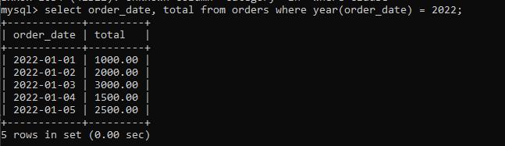

26) Write a query to retrieve the names and prices of all products that have the word "Smart" in their name.



27) Write a query to retrieve the names and countries of all customers who have not placed any orders.

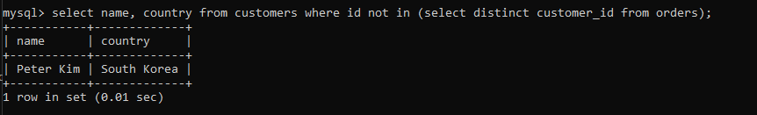

28) Write a query to retrieve the names and salaries of all employees who work in the "Marketing" department or the "IT" department.

select name, salary from employees where department in ('marketing', 'it');

29) Write a query to retrieve the order dates and total amounts of all orders placed by customers in the USA, ordered by total amount in descending order.

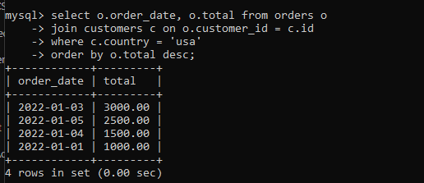

30) Write a query to retrieve the names and prices of all products that have a price between 100 and 500, inclusive.

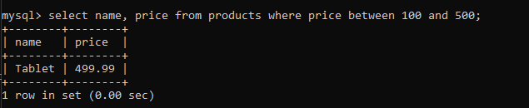

31) Write a query to retrieve the names and salaries of all employees who have a salary greater than the average salary.

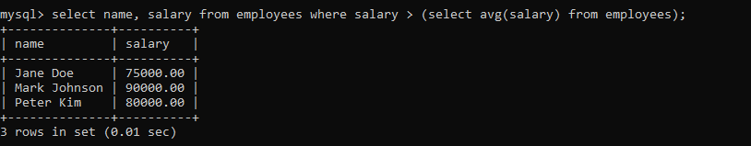

32) Write a query to retrieve the names and email addresses of all customers who have placed at least 2 orders.

select c.name, c.email from customers c

join orders o on c.id = o.customer_id

group by c.id

having count(o.id) >= 2;

33) Write a query to retrieve the names and ages of all employees who have a salary between 30,000 and 50,000, inclusive.



34) Write a query to retrieve the order dates and total amounts of all orders placed by customers who live in the same country as customer ID 5.

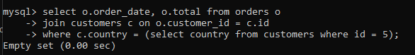

35) Write a query to retrieve the names and prices of all products in the "Electronics" or "Home" category.

select name, price from products where category in ('electronics', 'home');

36) Write a query to retrieve the names and salaries of all employees who have a manager ID of 3 or 4.

select name, salary from employees where manager_id in (3, 4);

37) Write a query to retrieve the names and prices of all products that have a name containing the word "Speaker".



38) Write a query to retrieve the names and salaries of all employees who have a manager ID that is not NULL.

select name, salary from employees where manager_id is not null;

39) Write a query to retrieve the order dates and total amounts of all orders placed in the month of January 2023.



40) Write a query to retrieve the names and prices of all products that have a price greater than the average price.

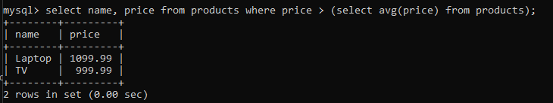

41) Write a query to retrieve the names and salaries of all employees who have a salary greater than 40,000 and a manager ID of 2.

select name, salary from employees where salary > 40000 and manager_id = 2;

42) Write a query to retrieve the names and email addresses of all customers who have placed an order in the year 2022 and have a country of "USA" or "Canada".

select distinct c.name, c.email from customers c

join orders o on c.id = o.customer_id

where (c.country = 'usa' or c.country = 'canada') and year(o.order_date) = 2022;

43) Write a query to retrieve the names and ages of all employees who have a manager ID of 1 or 3 and a salary greater than 35,000.

select name, age from employees where (manager_id = 1 or manager_id = 3) and salary > 35000;

44) Write a query to retrieve the order dates and total amounts of all orders placed by customers who have not placed an order in the year 2022.

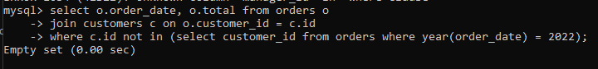

45) Write a query to retrieve the names and prices of all products in the "Toys" category that have a price greater than 10.

select name, price from products where category = 'toys' and price > 10;

46) Write a query to retrieve the names and salaries of all employees who have a manager ID that is not NULL and a salary less than 40,000.

select name, salary from employees where manager_id is not null and salary < 40000;

47) Write a query to retrieve the names and prices of all products that have a price less than the average price.

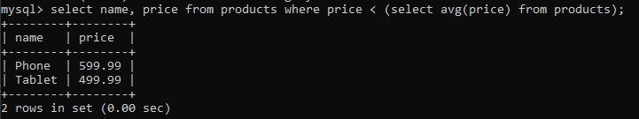

48) Write a query to retrieve the names and salaries of all employees who have a salary between 25,000 and 40,000, inclusive, and a manager ID of 1.

select name, salary from employees where salary between 25000 and 40000 and manager_id = 1;

49) Write a query to retrieve the order dates and total amounts of all orders placed by customers who live in the same country as customer ID 7.

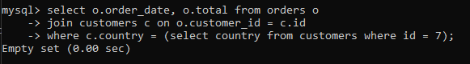

50) Write a query to retrieve the names and prices of all products in the "Home" category that have a price less than 200.

select name, price from products where category = 'home' and price < 200;

51) Write a query to retrieve the names and salaries of all employees who have a salary greater than 50,000 and a manager ID of 3.

select name, salary from employees where salary > 50000 and manager_id = 3;

52) Write a query to retrieve the names and email addresses of all customers who have not placed an order in the year 2023.

select name, email from customers where id not in (select customer_id from orders where year(order_date) = 2023);

53) Write a query to retrieve the names and ages of all employees who have a salary greater than 30,000 and a manager ID of 2 or 4.

select name, age from employees where salary > 30000 and manager_id in (2, 4);

54) Write a query to retrieve the order dates and total amounts of all orders placed in the month of May 2023.



55) Write a query to retrieve the names and prices of all products in the "Books" category that have a price less than 20.

select name, price from products where category = 'books' and price < 20;

56) Write a query to retrieve the names and salaries of all employees who have a manager ID that is not NULL and a salary greater than 45,000.

select name, salary from employees where manager_id is not null and salary > 45000;

57) Write a query to retrieve the names and prices of all products that have a price greater than the average price and are in the "Electronics" category.

select name, price from products where price > (select avg(price) from products) and category = 'electronics';

58) Write a query to retrieve the names and salaries of all employees who have a salary between 35,000 and 50,000, inclusive, and a manager ID of 2.

select name, salary from employees where salary between 35000 and 50000 and manager_id = 2;

59) Write a query to retrieve the order dates and total amounts of all orders placed by customers who live in the same city as customer ID 4.

select o.order_date, o.total from orders o

join customers c on o.customer_id = c.id

where c.city = (select city from customers where id = 4);

60) Write a query to retrieve the names and prices of all products in the "Clothing" category that have a price between 20 and 50, inclusive.

select name, price from products where category = 'clothing' and price between 20 and 50;

61) Write a query to retrieve the names and salaries of all employees who have a salary greater than 60,000 and a manager ID that is not NULL.

select name, salary from employees where salary > 60000 and manager_id is not null;

62) Write a query to retrieve the names and email addresses of all customers who have placed at least one order for a product with a price greater than 100.

select distinct c.name, c.email from customers c

join orders o on c.id = o.customer_id

join products p on o.product_id = p.id

where p.price > 100;

63) Write a query to retrieve the names and ages of all employees who have a manager ID of 1 and a salary greater than 40,000.

select name, age from employees where manager_id = 1 and salary > 40000;

65) Write a query to retrieve the order dates and total amounts of all orders placed by customers who live in the same state as customer ID 2.

select o.order_date, o.total from orders o

join customers c on o.customer_id = c.id

where c.state = (select state from customers where id = 2);

Write a query to retrieve the names and prices of all products that have a name starting with the letter "S".

Write a query to retrieve the names and salaries of all employees who have a salary less than 30,000 and a manager ID of 4.

Write a query to retrieve the names and prices of all products in the "Home" category that have a price greater than 50.

Write a query to retrieve the names and salaries of all employees who have a salary between 20,000 and 35,000, inclusive, and a manager ID of 3.

Write a query to retrieve the order dates and total amounts of all orders placed by customers who live in the same country as customer ID 10.

Write a query to retrieve the names and prices of all products in the "Toys" category that have a price between 5 and 15, inclusive.

Retrieve all records from the products table where the category column is equal to 'Electronics'.

Retrieve the total number of orders placed by the customer with customer_id 1001.

Retrieve the top 5 best-selling products from the orders table.

Retrieve the order_id, product_id, and quantity of all orders where the quantity is greater than or equal to 10.

Retrieve the product_name and unit_price of all products with a unit price greater than $50.

Retrieve the customer_name, order_id, and order_date of all orders placed by customers who live in the state of California.

Retrieve the order_id, product_id, and quantity of all orders where the quantity is less than or equal to 5.

Retrieve the customer_id, customer_name, and total_spent of the top 10 customers who have spent the most money.

Retrieve the product_id and product_name of all products that have never been ordered.

Retrieve the customer_id, customer_name, and order_date of all orders placed by the customer with customer_id 1002.

Retrieve the order_id, product_id, and quantity of all orders where the order_date is between '2022-01-01' and '2022-12-31'.

Retrieve the category and the total number of products in each category.

Retrieve the customer_name, order_id, and order_date of all orders placed by customers who have spent more than $500.

Retrieve the product_id, product_name, and the total revenue generated by each product (quantity * unit_price).